APARTMENTS FOR RENT

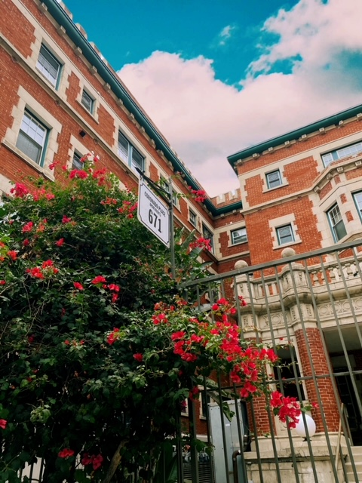
2 BEDROOMS
Alegria Apartments
801 W. 23rd Street, Los Angeles, CA 90007
1 BEDROOM
39th Street Apartments
1230 W. 39th Street, Los Angeles, CA 90007

4 BEDROOMS
Budlong Apartments
2727 S. Budlong Avenue, Los Angeles, CA 90007
3 BEDROOMS
Amistad Apartments
1953 Estrella Avenue,
Los Angeles, CA 90007

Apply on-line at: rentvistawest.com
Or
Call Vista West Properties at 213-441-1800 if you or your family would like to complete a paper form for low-income apartments. When you call our offices, our staff can answer questions regarding apartment availability, rent, income requirements or restrictions and how to obtain an application for housing.

